CROSS ENTROPY:
It is a loss function that helps to measure and improve the performance of a model, when we do supervised learning then this will be very helpful. The main focus of a model is to reduce the no of loss function.
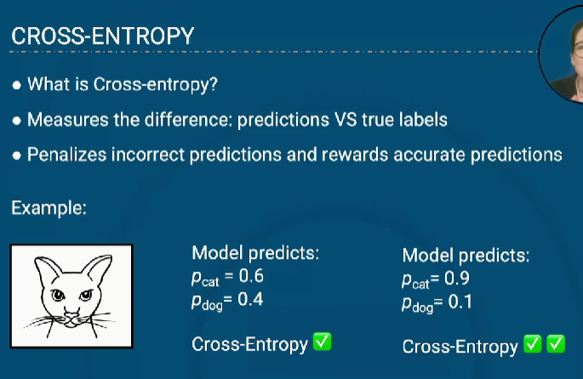
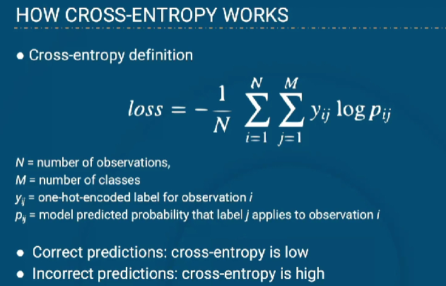

Y is the label that the target class have, if have cat then ycat will be 1, if we doesn’t have cat then it will be 0. Pcat, pdog is the prediction of our model.
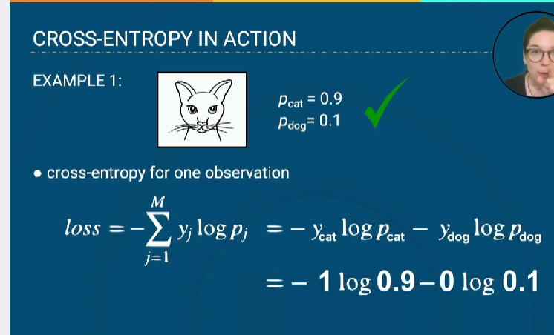
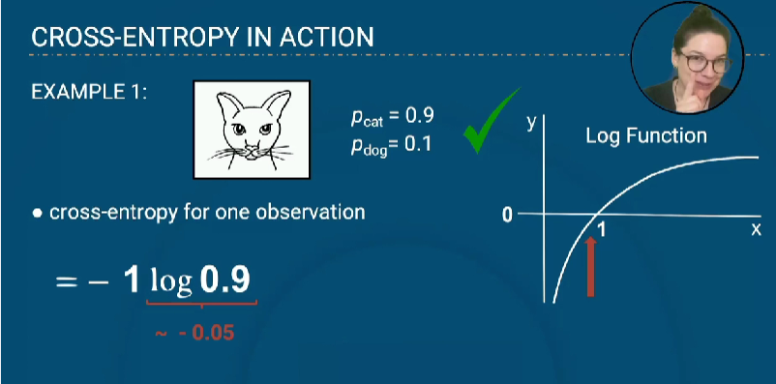
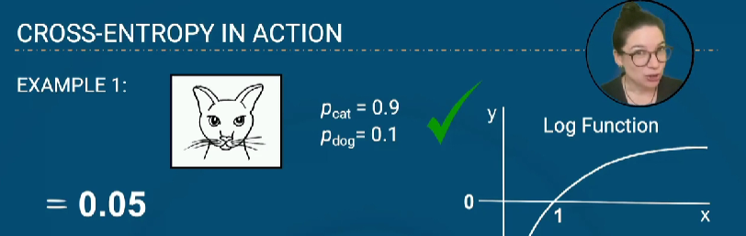
Example for wrong cross entrpy
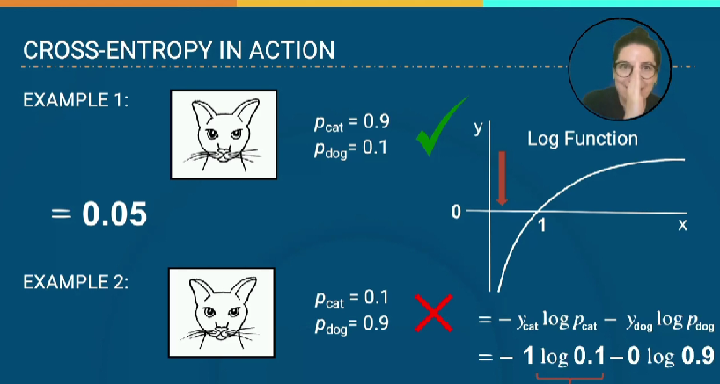
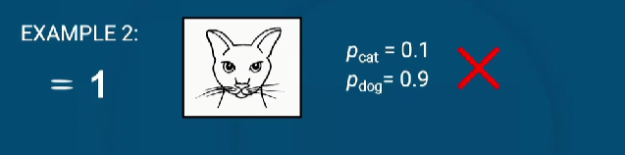
So the cross entropy are increased in wrong prediction and decreased on correct prediction, cross entropy works in following things
